|  |  |  |  |
| --- | --- | --- | --- |
| **Canterbury High School News** 80 Main Street, Canterbury, NB. E6H 1L3 | | | December 2014  & January 2015 |
| **Vice- Principal:** Mr. Jeff Tompkins **Phone:** 279-6000 **Website:** <http://web1.nbed.nb.ca/sites/district14/chs> **Principal:** Susan Mabie Important Dates December  4th 7-9 pm Formal Winter Dance for  Grades 6-12 (Semi formal**) $5.00**  Hot chocolate, ice cream cake, veggie trays included in $5.00.    5th “Ring-A-Bell” campaign for K-8.  Students in K-8 will be participating  In a province wide awareness &  educational campaign for mental  health. The Dots for Kids day –Ring a Bell campaign is a unique opportunity for students to learn about the importance of positive mental health. Students will  ring a bell for one minute in support of kids’ mental health.  11th Free “Christmas Dinner” students and staff sponsored by Krissi Helping Community. Please remember there will not be cafeteria on December 10th.  16th K-5 celebrate the holiday season  With our Chistmas concert, ”Twas the Night Before Christmas”. There are two shows at 9 am & 1:30 pm. Students will wear pyjamas all day due to the theme.  **Storm date is Wed., Dec. 17th**  19th **LAST DAY OF SCHOOL** before  Christmas Break. *Remember to bring in nonperishable items for  the Food Bank.  **JANUARY 2015**  5TH No school for students. Professional Learning Day for  Teachers  6th First day for students after break.  19th- 23rd Exam Week grades 9-12  26 & 27th Turn-Around Days (No School for students in grades 9-12.) | | | |
|  | **Winter Carnival Dec 15- 19th**  **Dress Up Days:**  **Monday – school spirit day – blue & gold**  **Tuesday – pajama day**  **Wednesday- dress up as favorite TV, Movie, Novel Character**  **Thursday – crazy hair & crazy make up day (face paint)**  **Friday – Camo or 80’s dress up day**  **New Website with Twitter Feed**  **http://web1.nbed.nb.ca/sites/ASD-W/chs/Pages/default.aspx**  **All athletic and extra- curricular events are posted on our website, videos, pictures, and school info will be updated regularly. We hope parents sign up for our Twitter feed so you get reminders, last minute cancellations and messages to your mobile device.**  **\* * * * * \***  **C:\Users\dickina\AppData\Local\Microsoft\Windows\Temporary Internet Files\Content.IE5\KBGMA0X8\MC900441560[1].wmfThanks to the following CHS Athletics’ sponsors:**  Cummings Bros. & Son  Village of Canterbury  Village of Meductic  Murray’s Irving  DSL Engineering  Ayr Motors  Reg Keilty Ltd.  Gauvin’s Flooring  Garnet’s Welding  NBCC Woodstock  Susie’s Photography  Stairs Building Ltd.  Creative Advertising  Fillion Forestry Ltd.  Esso Source Centre  Keilty’s Complete Septic Services  *************************************  **Guidance News: Grads are reminded to check our CHS website for updates on scholarships, deadlines, etc.** | | |
|  | | |
|  |  |  |
|  | | |
|  |  |  |

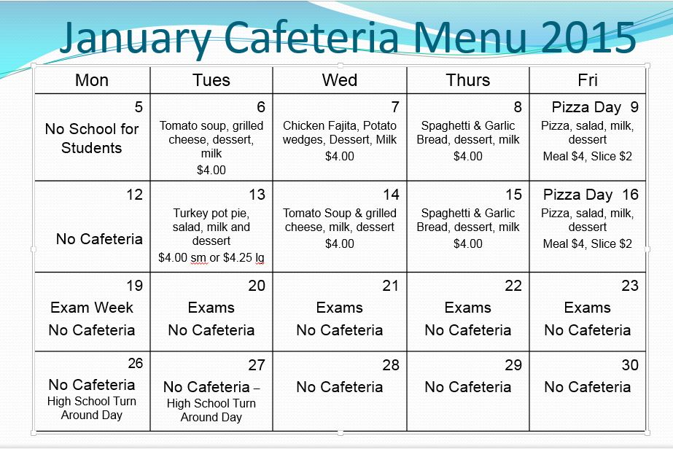

**Exam Week Jan. 19 – 23, 2015**

**Time of Exams: Exams begin each day at 9:00 am and will be 2 hours in length. Students may not leave prior to 11:00 am. 8:30-9:00 each morning is time for students to ask any questions, have a break and prepare. Students will be given up to one additional hour (12:00 pm) to write.**

**Study Hall- Each afternoon there is a supervised study hall. Students who stay will sit in their exam until noon and may study for their next exam. Students report to study hall for the afternoon. Students who leave school property following their exam and for the afternoon may not return to catch the bus at the end of the day.**

**Grade 9 Students- Students need a note if they will be picked up or plan to leave following exams. One note to Mrs. Dolimount for the week will be fine.**

**Storm Day - Should there be a storm day during the exam schedule, the order of exams will not change. They will be simply pushed ahead a day. Ex. If Tuesday is a storm day, the Tuesday exams will be written on Wednesday and the Wednesday exams will be written on Thursday and so on. Friday exams would be moved to Monday and there would be only one turn around day instead of two.**

**January 26th and 27h – Turn Around Days- For grades 9-12 only – no school unless there ends up being an exam Monday due to a storm day during exam week.**

**Exam Schedule**

|  |  |  |  |  |  |
| --- | --- | --- | --- | --- | --- |
|  | **Monday, Jan 19** | **Tuesday, Jan. 20** | **Wednesday, Jan 21** | **Thursday, Jan 22** | **Friday, Jan 23** |
| AM | Pre-Calculus 12A  Pre-Calculus 11  10 English  Workplace Math 110, 120 9 ELPA - Reading | English 112/122  English 113/123  9 Math  10 History | Math Foundations 11  9 Science  World Issues 120  10 Math | ELPA- Writing II  10 Science  Biology 112 & 113 | 9 French  112 Chemistry  Metals 110 & 120  Health & PE 110 |